Name | JOSEPH FOSTER APPLEBY
Birth | 1892 Wylam
Enlistment/Occupation | Enlisted Prudhoe, Northumberland / Compositer
Death, date, location | 18/09/1916  Died of wounds  France & Flanders  Hook trench, Mametz Wood.
Age | 24
Unit, rank, service no: | 2599  Private  Enlisted in 3rd/4th Batt.  Northumberland Fusiliers and then transferred to1/4th Battalion (Territorials) Northumberland Fusiliers
Photograph Hexham Courant 18/11/1916 | 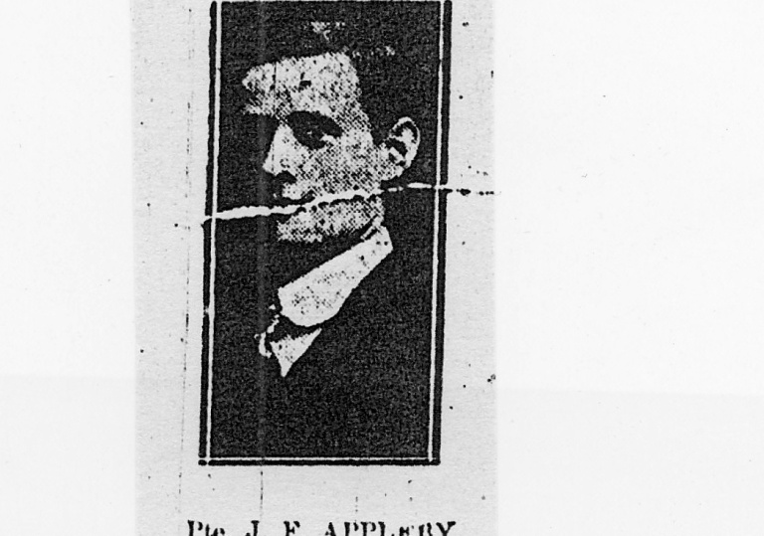
Family Acknowledgement  CWGC | Son of George Foster Appleby and Annie Appleby; husband of Elizabeth Mary Waugh (formerly Appleby), of Ovington Cottage Lodge, Ovington, Prudhoe Station, Northumberland.
Photograph of Joe (May) Appleby and his wife Elizabeth Mary (nee Jackson) 1915?  Photograph supplied by family Colin & Eileen Hawkshaw. | 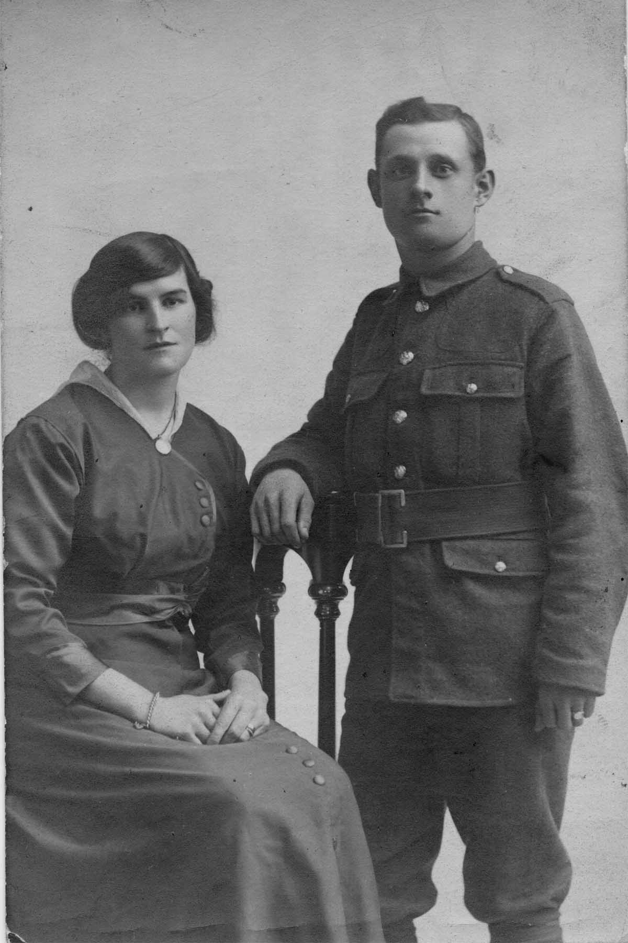
Family | Eldest of three sons of George Foster Appleby and Annie Appleby (nee May) of Wylam who married at St. Oswin’s church, Wylam on 31st March 1888. The family lost two sons in WWI Joseph Foster and George Oswin who served in 1/4th Battalion Northumberland Fusiliers. George Oswin died at home 12/02/1917. (See separate entry under George Oswin Appleby)  1901 Census shows Joseph’s parents George Foster & Annie Appleby living at 24 Prospect Terrace, Prudhoe. Father George aged 39 works as a Master Shifter below ground, mother Annie is aged 34. In same census Joseph Foster aged 9 was staying with his maternal grandparents Stephen May 57 (who works above ground at colliery) and Frances May 59 at their home 11 Ingham Terrace, Wylam.  In 1910, when Joseph’s younger brother George Oswin first joined the territorial army, the family address given by George Oswin on his enlistment papers was 10 Halfway Houses, Prudhoe. However, both brothers attended Wylam school even though Joseph lived in Wylam with his grandparents while George Oswin lived in Prudhoe with the rest of the family.  1911 Census shows Joseph Foster still at his grandparent’s house at 11 Ingham Terrace aged 19 and his occupation given as Apprentice Compositer in printing trade.  The census returns show that George Foster and Annie Appleby had six children Joseph Foster b.1892, Wilfred b.1894, George Oswin b. 1897, Doris b.1901, Rita b. 1903 and Aileen b. 1905.  The actual date of Joseph’s enlistment in the Northumberland Fusiliers at Prudhoe has not been traced nor the actual date he was sent to France, but it seems probable that his marriage in Spring 1915 took place before departure. The 1/4th Bn. Northumberland Fusiliers entered France on 20th April 1915.  A Memorial Service was held in St.Oswin’s church, Wylam Sunday 5/11/1916 and was reported in the Hexham Courant 11/11/1916. The service was held to commemorate Fred Hunter, Joseph Appleby, Jacob (Jake) Irwin, Jack Winder, John William Young, Alex White & Joseph McCarthy all casualties of the Somme battles. The report makes special mention of the fact that Joe Appleby was known in the village as Joe May because he was reared in Wylam by his loving grandparents. Joe had been employed at Mssrs Ward & son, printers, Newcastle. He had been a member of the church choir and the Church Lads Brigade. He was also a bell-ringer. The report also makes mention of the distress of Joe’s young wife Mary, at the service.  Joe’s father was George Foster Appleby, Band Master of the 4th Bn. Northumberland Fusiliers.  The CWGC record shows that Joseph Foster had a wife Elizabeth Mary Waugh (formerly Appleby), of Ovington Cottage Lodge, Ovington, Prudhoe Station, Northumberland. The marriage records show that Joseph Foster Appleby and Elizabeth Mary Jackson married in Hexham district in the April/May/June quarter 1915. It would seem that by the time of the CWGC records were produced after Joseph’s death, Elizabeth Mary had remarried and her name was changed to Elizabeth Mary Waugh.
Battalion War Diaries of 1/4th Nn. & 1/7th Bn. Northumberland Fusiliers | Battle of Flers-Courcelette, 15th to 22nd September 1916.  The Battle of Flers-Courcelette was the third and final offensive of the battle of the Somme and commenced 15th until 22nd September when the fighting was called off. The original grand objectives of creating a break through the German lines were abandoned, but some local advances and tactical advantages were achieved.  Hook trench near Mametz Wood was given as the location where Joseph was wounded and he subsequently died from those wounds in September 1916. Mametz Wood was an objective early on in the Battle of the Somme which commenced 1st July 1916 and lasted until 18th November 1916. This area of the battlefield appears to have been fought over on more than one occasion during that period.  The date and location where Joseph suffered his fatal wounds are known and the following information has been pieced together from the war diaries of the 1/4thBn and 1/7thBn. Northumberland Fusiliers who took part in the action at Hook Trench. This particular action, involving the 4th Btn N.F., 7th Btn N.F. and later that day the 9th Btn D.L.I., had three successive German held trenches as objectives. The 1st objective was HOOK TRENCH, the 2nd objective was STARFISH TRENCH and the third objective was PRUE TRENCH. The British held CLARK TRENCH was the start line for the 4th Btn N.F. who commenced the assault at Zero Hour 6.20 am 15th September 1916.  The war diaries for the 4th Battalion and the 7th Battalion Northumberland Fusiliers describe a period of action from the 1st – 18th September 1916 in the area of Mametz Wood. Hook trench was a first objective of an attack by Joseph’s battalion when the assault commenced 15th September. The 4th Battalion NF had gone into action with 23 officers and 695 other ranks. During this period of action the 4th Battalion lost 17 officers & 110 men killed, 229 men wounded and 143 missing. The 7th Battalion NF lost 3 officers & 40 men killed, 219 men wounded and 74 missing.  In addition to Joseph it would seem that other men commemorated on Wylam memorials were killed or mortally wounded in this same action including John William Young & Alexander White 1/4th NF, Frank McKenna 7th Battalion NF and Jack Winder 9th Battalion Durham Light Infantry. Plus John Lishman Hart 4th Battalion NF who lived in Wylam at the time of his enlistment was also killed, but he is commemorated elsewhere on the Ryton War Memorial.  Later that September another Wylam casualty, Joseph Edward McCarthy was lost at Thiepval Ridge, on the Somme, 26th September 1916.  These losses prompted an entry by Ralph Brady Headmaster into Wylam School Log Book p.183-184, 23/10/1916.  ‘Received information of death of Pte Jacob Irwin on 15th September killed in action, of Joseph McCarthy killed in action on same date and of Joseph F. Appleby (better known as May) who died of wounds three days after the action on 15th September. These old scholars who have made the great sacrifice for their King & Country were all in the 4th N.F.’  (Not all of the detail information in this last entry is entirely correct, but that is understandable given the often delayed and sometimes confused state of the notification process.)  A further three Wylam casualties had already been sustained on the 1st July, the first day of the Battle of the Somme, they were Frederick Hunter, James Leadbitter Knott, and Joseph Pattinson. (see ref: to individual names)
Battalion | The 1/4th Battalion, Northumberland Fusiliers, a territorial battalion was based in Hexham when war broke out in August 1914. After training they proceeded to France in April 1915, to join the 149th Brigade, 50th (Northumbrian) Division. They took part in the Second Battles of Ypres in 1915 and the Battle of the Somme in 1916, the Arras Offensive where they captured Wancourt Ridge and The Second Battle of Passchendaele in 1917. In 1918 they again saw action on The Somme and Battles of the Lys and Hindenburg Line.
Memorials | IV E9  Heilly Cemetery  Mericourt – L’Abbe, France.  Also commemorated on:-  School War Memorial Plaque, Falcon Centre Wylam  War memorial Plaque St.Oswin’s church, Wylam  War Memorial Monument, Village Green,Wylam  Roll of Honour Central Council of Churchbell Ringers  George Foster Appleby, the father of Joseph Foster and George Oswin was the band master of the 1/4 Bn. Northumberland Fusiliers and the Prudhoe Military Band who played at the unveiling ceremony of the Wylam War memorial monument on 10th March 1923.
Sources | UK Soldiers died in the Great War 1914-1919 Commonwealth War Graves Commission  1891/1901 &1911 Census.  England & Wales Marriage Index  Wylam School Log Book 23/10/1916  Hexham Courant 18/11/1916  War Diaries 4th & 7th battalions Northumberland Fusiliers, Fusiliers Museum of Northumberland, Alnwick.

